Software Requirements Specification
For

Railway Reservation System

Version 1.0 approved

Prepared by

Bhuvan M S [12IT16]

Siddharth Jain [12IT78]

Vinay Rao D [12IT94]
March 17, 2014

Table of Contents
Table of Contents ii
Revision History ii
1. Introduction 1
1.1 Purpose 1
1.2 Project Scope and Product Features 1
1.3 References 1
2. Overall Description 1
2.1 Product Perspective 1
2.2 User Classes and Characteristics 1
2.3 Operating Environment 1
2.4 Design and Implementation Constraints 2
2.5 User Documentation 2
2.6 Assumptions and Dependencies 2
3. System Features 2
3.1 Main Login 2
3.2 Admin 2
3.3 Clerk 3
4. External Interface Requirements 4
4.1 User Interfaces 4
4.2 Hardware Interfaces 4
4.3 Software Interfaces 4
5. Other Nonfunctional Requirements 4
5.1 Performance Requirements 4
5.2 Safety Requirements 4
5.3 Security Requirements 5
5.4 Software Quality Attributes 5
Appendix A: Use Case Diagram 6
Appendix B: Analysis Models 7

Revision History
Name | Date | Reason For Changes | Version
Bhuvan M S | 25/02/14 | initial draft | 1.0 draft 1
Siddharth Jain | 26/02/14 | feature to booking ticket overlooked | - draft 2
Vinay Rao D | 28/02/14 | non functional requirements, use case diagrams | 1.0 draft 3
Siddharth Jain | 28/02/14 | minor corrections related to GUI design | 1.0 draft 4
Bhuvan M S | 10/03/14 | Verification | 1.0 approved

Introduction

Purpose
This SRS describes the software functional and nonfunctional requirements Railway Reservation System. This document should be used by the project team members to implement and verify the correct functioning of the system.

Project Scope and Product Features
The Railway Reservation System will permit customers to check availability, book and cancel tickets with the help of clerk. The administrator’s functions are to add employee and maintain a record for trains (i.e. Add/ remove trains).

References
- Sierra, Bates, Head First JAVA
- Ali Brahmi , Object Oriented Systems and Developement

Overall Description

Product Perspective
The Railway Reservation System is a software system used to book, cancel tickets and other basic functionalities that a Railway System must provide. The customer is provided direct services by clerk to perform this activities while Admin provides indirect services like adding/removing trains, adding/removing employees etc.

User Classes and Characteristics
Clerk | Clerk provides client services like booking/cancelation of tickets. If a person has to book tickets, ours system’s clerk first checks train availability and once confirmed, performs the specific action client is requesting for.
Admin | Admin has the power of adding new employees (which can either be clerk or a new admin). Admin maintains train record (add/remove trains) and keeps updating as required (booking cannot take place before a month of travel etc.)

Operating Environment
OE-1: The Railway Reservation System can operate with the following Operating Systems: Windows XP, 7, 8; Linux (with Java support).

Design and Implementation Constraints
CO-1: Ticket can be booked at maximum a month before the booking date
CO-2: Clerk Should be registered employee(i.e. should use ID and password assigned by admin)
CO-3: All code shall be written in Java using Object Oriented Principles.

User Documentation
UD-1: The system is based on functionality represented by API’s in Standard JAVA documentation

Assumptions and Dependencies
AS-1: Clerk will perform all the operations requested by customer for customer.
AS-2: All the trains have to be added before booking any ticket.

System Features

Main Login

3.1.1 Description and Priority
Main screen shows up with the option of logging in. Using the employee ID and password, the employees try logging in and are redirected to respective windows (to clerk window if a clerk and to admin window if employee is an admin).If the ID and password do not match, the login is considered as invalid and will not be redirected.

3.1.2 Stimulus/Response Sequences
Stimulus: Employee enters his/her ID and password.
Response: If the login is correct then it is checked whether the ID is of an admin or a clerk. If admin, the admin is redirected to the admin window and if a clerk, the clerk is redirected to his window.
Stimulus: Login was invalid
Response: Not redirected to any page and informed that the employee has entered either the wrong ID or password.

Admin

3.2.1 Description and Priority
An admin whose identity has been verified will be redirected to his window

3.2.2 Stimulus/Response Sequences
Stimulus: Admin clicks on the button add train
Response: Window appears asking details about the train.
Stimulus: Admin clicks on the button add employee
Response: Window appears asking details about the employee and the type of employee.
Stimulus: Admin clicks on button remove train
Response: Window pops up asking for train no.
Stimulus: Admin clicks on the button update master record
Response: The master record of train is updated.(Date is moved forward so that the booking restraint of one month makes one new day eligible for booking of tickets. This has to be done every day so that booking system can work perfectly and efficiently)

3.2.3 Functional Requirements

AddTrain: The system shall let the Admin who are logged into the Railway Reservation System add a train and will ask admin to fill in details.
RemoveTrain: The system shall let the Admin who are logged into the Railway Reservation System remove a train with respect to its number.
AddEmployee: The system shall let the Admin who are logged into the Railway Reservation System add an employee and fill the details regarding the new employee.
UpdateMasterRecord: The master record of trains is updated.

Clerk

3.3.1 Description and Priority
A clerk whose identity has been verified may reserve/cancel ticket as requested by client.

3.3.2 Stimulus/Response Sequences
Stimulus: Client requests user to book/cancel a ticket
Response: clerk requests confirmation.
Stimulus: client provides confirmation.
Response: Clerk fills in the information provided in required window pop up. Tells the status of the train to client
Stimulus: client confirms to book/cancel the ticket based on the response of the clerk.
Response: A message is generated depending upon the action of course taken.

3.3.3 Functional Requirements

CheckAvailability: The clerk fills the details about travelling, and selects a train and then shows the availability or waiting status of the train to client for the day client asked.
ReserveTicket: If available, and client wants to book the ticket, clerk books ticket.
CancelTicket: If the ticket was already booked, then on request of client, clerk can cancel the ticket.

External Interface Requirements

User Interfaces
UI-1: The System shall provide above mentioned functionalities in a very friendly manner by implementing GUI(Graphical User Interface) using JAVA window builder

Hardware Interfaces
No hardware interfaces have been identified.

Software Interfaces
SI-1: Railway Reservation System
SI-1.1: Java’s collections API is used to manage data..

Other Nonfunctional Requirements

Performance Requirements
PE-1: The Railway Reservation System allows one clerk to handle user queries from 12:00 to 23:30.
PE-2: Responses to queries shall take no longer than 2 seconds to load onto the screen after the user submits the query.
PE-3: The system shall display confirmation messages to users within 1 seconds after the user submits information to the system.

Safety Requirements
No safety requirements have been identified.

Security Requirements
SE-1: Admin shall be required to login to the Railway Reservation System for all operations.
Clerk shall login according to the restricted computer system access policy.
System automatically identifies clerk/admin based on login data.
SE-2: The system shall permit only the admin to add a new train/employee.
SE-3: Data is encrypted according to java object serialization and stored in main server in non-readable form

Software Quality Attributes
Availability-1: The Railway Reservation System shall be available at the clerk’s end between 00:00 and 23:30. From 23:30 to 24:00, admin will update the server for the next day.
Robustness-1: Railway Reservation System master record uses nested hash maps to store reservation and train data. Hence all the responded quickly.
Reliability-1: Data is persistent as the master record gets updated for each transaction and gets stored in serialized form.

Appendix A: Use Case Diagram

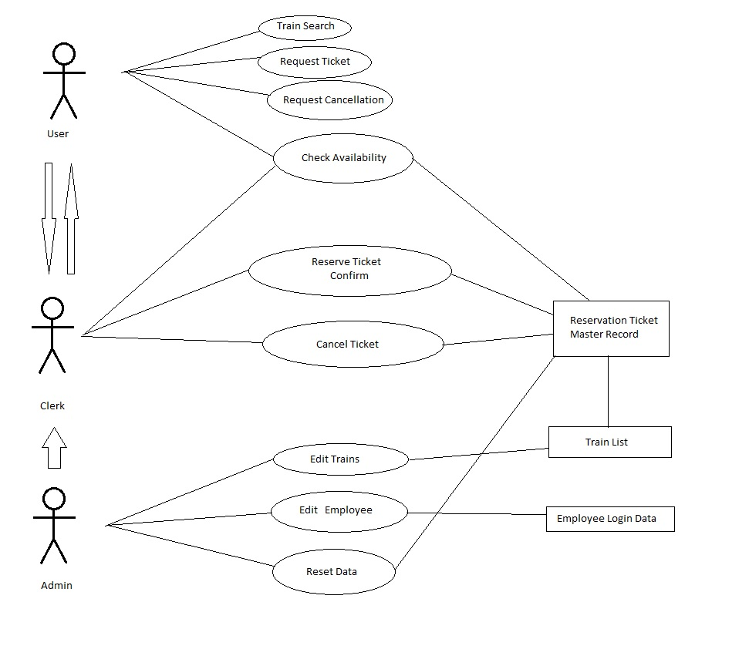

Fig2: Use Case Diagram for Railway Reservation System

Appendix B: Activity Models

